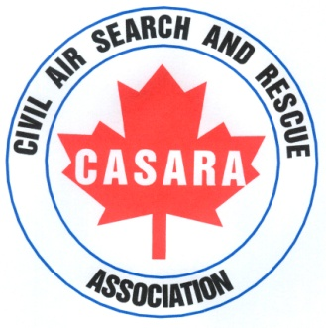
CASARA
Zone 2, Brandon

Annual Newsletter

March 2013 – March 2014

Zone 2 has had another busy year of training: if you missed the exercises, you also missed all the fun.

March 27, 2013
Finished off our 2012/13 year with a big exercise utilizing all our members’ skills with three aircraft and Ground Search Teams
The scenario was a missing aircraft on skis with three hunters on board, the search concentrated in the Pelican Lake area.

April 28, 2013
The objective of this exercise:
Try out the new Electronic Locator Transmitter (ELT) direction finder fitted to a Search Aircraft.
Two CASARA aircraft, were assigned to search for two separate missing aircraft in the Brandon to Carberry & Minnedosa to Neepawa area.
Crews were assigned two different search patterns as well as ELT signal search.
Ground Target Team set up a crash site with multiple targets and crash debris.
The objective was to count how many different items were at the crash site.
The crash site was made up of a vehicle, Aircraft simulated debris, coloured markers & tarps, Body shapes and active victims. Tracks in snow, reflective surfaces & strobe lights.
At the debrief it was noted that not all the signs were spotted due to homing in on the main crash site.
Ground Team successful in their search with good communications between Air & Ground

May 4, 2013
RCMP call for request to search for missing child in the Sidney area west of Portage la Prairie.
CASARA responded with one crew assigned & ready to dispatch when RCMP informed that the child was found safe and CASARA crew informed to stand down.

May 8, 2013
Training exercise with two CASARA aircraft, each crew successfully in their Sector
Search & River Crawl patterns and ELT signal search.

May 22, 2013
Memorial Service for Wayne Gray, a Zone 2 member involved in a tragic vehicle accident.
Wayne was a Major stationed in Portage la Prairie flying the Expeditor. He moved on to Winnipeg in Training Command HQ. The following 10 years spent in Trenton, flying the Hercules and Boeing707.He Transferred to Germany spending 4 years flying AWACS.
He was a Military Observer for the U.N in Egypt followed by a UN Liaison Officer. Three years spent in National Defense in Ottawa before returning to Trenton to fly the 707 until its retirement.
After Wayne’s retirement, he worked on coordinating simulator flight training for the military. He had recently joined CASARA and it was our privilege to work with him.

May 29, 2013
Training exercise for currency with one CASARA aircraft tasked to do an Expanding
Square and a Track Crawl between Gladstone and Brandon.

June 15, 2013
CASARA members supported Brandon Flying Club at their 8 am Fly in Breakfast
The CASARA display stand was prominent and members answered questions and chatted about our organization.
An academic exercise commenced at 9.30 am.
Members discussed and planned a route with all the maps & navigation required. It was well received by the spotters taking part to see how the process is organized and it was noted that it kept the whole team involved, which is the object of our exercises.

June 19, 2013
One CASARA flight & ground target set out to train crew to meet currency requirements.

July 14, 2013
Casara members supported Souris Fly in Breakfast and chatted to members of the public
about the organization. Two Ground teams continued with a ground homing and
navigation exercise.

July 21, 2013
Zone 2 members were to visit the SAR base 435 Squadron in Winnipeg; unfortunately, the Hercules was called away on a mission the morning of our visit.

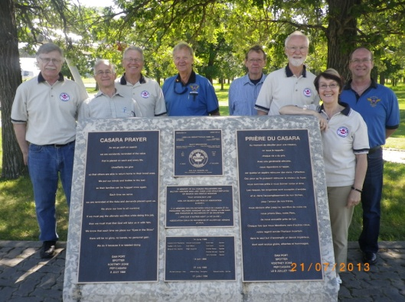
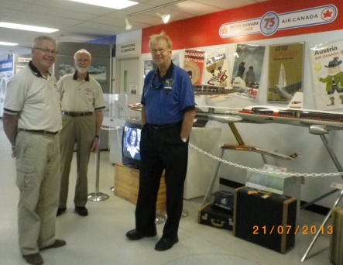
Our visit to Winnipeg went ahead with two vehicles leaving Brandon for a planned visit to the CASARA and Military Memorial. We continued on to enjoy an afternoon at the Aviation Museum.
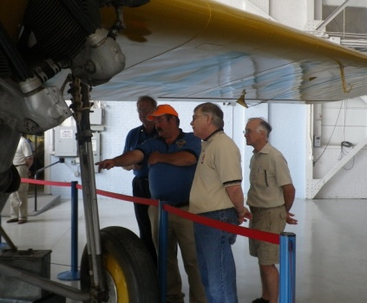
The tall tales, expertise and amazing personal history that
Zone 2 members shared was fascinating and would fill the
pages of a book that would interest even non-aviation
readers.
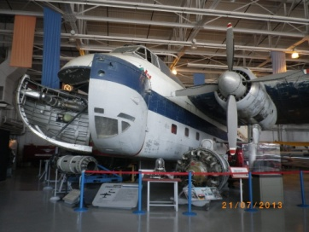
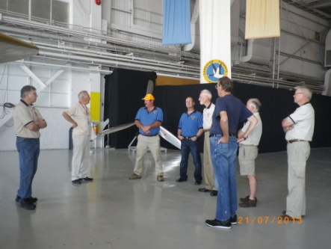

Our visit to the museum was a welcome change from training.
It was a good opportunity to share stories and achievements and get to know each other in a more relaxed setting, as well as seeing some great aircraft.

July 27, 2013
Exercise for currency training for navigator, from Brandon –Killarney to include a Sector Search, River Crawl and ELT signal search.

August 1, 2013
Exercise for currency training for navigator from Brandon to Glenboro to include Parallel
Track and Sector Search around the Spruce Woods area.

August 2, 2013
Exercise for currency training for navigator and spotters. Two flights from Brandon to Virden to include Track Crawl, River Crawl and expanding Square.

August 6, 2013
Exercise for navigator training in preparation for the Western SAREX next week. Expanding Square over Wellwood Area and ELT signal search with Ground Search Team.

Aug 9-10-11, 2013
Two Brandon aircraft heading to the Western SAREX at Yorkton in Saskatchewan for two days of training exercises involving teams from across Western Canada.
Aug 9, arrived in Yorkton for briefing and collected information, spent the evening working on maps and navigation etc.

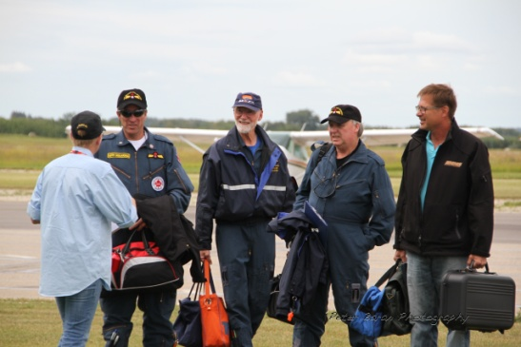
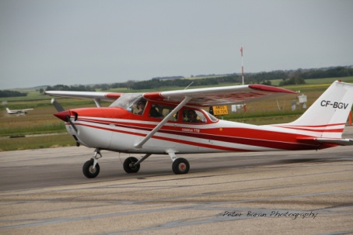
The Provincial Manitoba crew.
Pilot - Brad Wells,
Nav – Ken Fox.
Spotters
Doug Preston & Gerry Desjardin
from Zone 1.

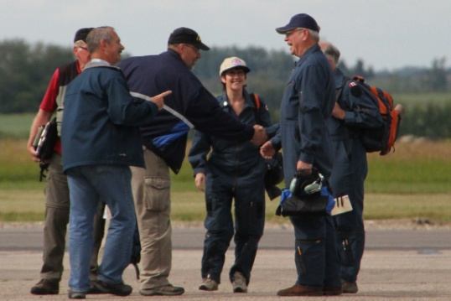
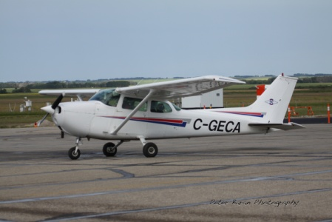
Zone 2 crew.

Pilot – Garry Gerrard,
Nav – Bev Williams, Spotters
Harold Doran &
Rene LeGal.
Aug 10, 11 2013
Thirteen aircraft from across Manitoba Saskatchewan and Alberta took part with each
Crew receiving an envelope with our designated CSAD section and details of our search
pattern. Some crews had an extra envelope to open with
a mid-air re-tasking.
BBQ lunch at base and new envelopes for the afternoon exercise. Numerous targets were spotted and logged until return to base.
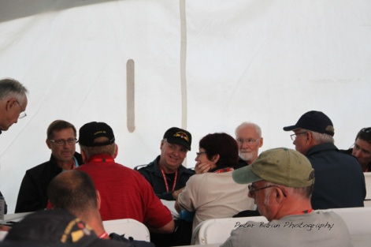
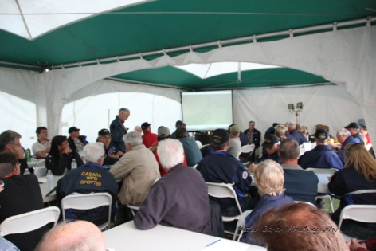

Watched the SAR Hercules land & STARS helicopter and SAR Techs show off their skills

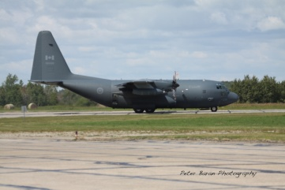
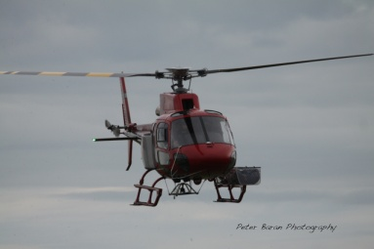
A very good buffet
meal in the evening by
local ladies.
Discussions on the days
exercise and
presentations for
volunteers followed by
a slideshow of photos
taken throughout the
two days.

Aug 11, 2013
Breakfast at the hotel then received an extra tasking for our trip back to Brandon,
successful pattern and target found and logged. Arrived back in Brandon late morning.
Aug 9, 10 & 11 was a very successful weekend of training, excellent organization from the Yorkton group from hotel shuttles to meals to the search briefing and packs. It was an opportunity for all members, new and experienced to get together and everyone benefited from the weekend and had a lot of fun in the process.
Aug 24 & 25, 2013
Three CASARA members joined a two-day Red Cross Wilderness Survival Course in Brandon; it was an academic and practical course and is an invaluable experience for all Search and Rescue personnel.

Sept 13, 2013
435 Squadron requested an Intercept Training Exercise for the afternoon. One aircraft took part with three crew members, they started with a search pattern procedure without knowing where or when the Intercept would take place. It was a successful training exercise and good practice for CASARA crew.

Sept 15-21, 2013
National SAREX took place in Gimli. one Zone 2 member attended as a spotter.

Sept 22, 2013
Exercise based on GSAR Wilderness Survival/ First Aid held in Aug. Brandon Regional Search and Rescue set out a crash site. CASARA Aircraft were dispatched as well as a Ground Search Team.
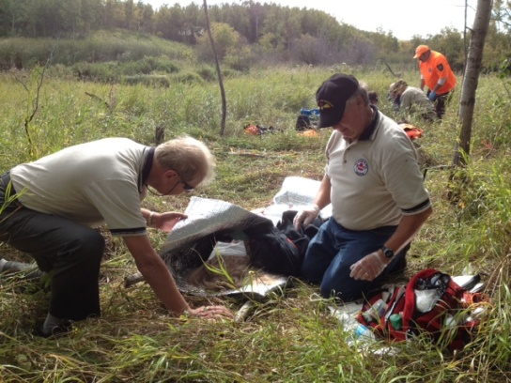
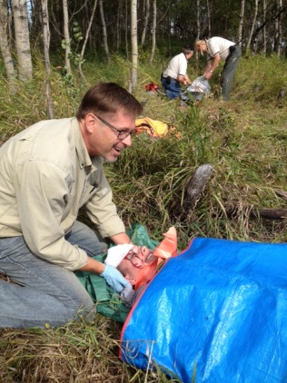
Once the crash site was found the ground crew had to perform first aid and survival techniques until emergency services could reach the site.
The exercise went very well with some scary ‘surprise accidents’ to test members skill under stress.

Oct 6, 2013
Training exercise with one flight crew and a Ground Search team dispatched to find target in the Ingelow to Gladstone area with a re-task mid pattern to search for an ELT signal.

Oct 12, 2013
Zone 2 Executive worked on administration, exercise files, forms, crew packages and inventory to have everything up to date in preparation for the Zone Evaluation on Oct 26.

Oct 22, 2013
Intercept exercise with 435 Squadron Hercules, one CASARA aircraft dispatched.

Oct 23, 2013
Ground Homing Training, four members took part.
Oct 25, 2013
Evening briefing from JRCC / Captain Ben Toenders, CASARA Liaison Officer with 435 Squadron for evaluation tomorrow. One CASARA aircraft and two simulated aircraft and one ground search team assigned for the exercise

Oct 26, 2013
Zone Evaluation went ahead with a good turnout of members. Crews worked well together and in control of all search teams, actual and simulated. Communication was good as was record keeping. Flight crew homed in on ELT signal and directed the ground team to the target.
Captain Toenders gave his review and informed Zone 2 that we had passed our evaluation.

Nov 3, 2013
Training exercise for radio basics and currency flight.

Nov 23, 2013
Tri-Zone Training Course in Dauphin. Thirteen members attended this academic course, covering navigation Ozi Explorer & SHQ, Spotter Simulator, ELT, “First on scene” as well as Debriefs, Cockpit Resource Management and Search Coordinator.
The Course was an excellent way to bring all Zones together and a good way of covering multiple subjects and gaining more confidence and expertise in all our CASARA positions.

Dec 8, 2013
435 Squadron Spotter training, nine members signed up and became certified as Military Spotters.

Jan 4, 2014
The CVT Spotter Simulator Designers were in Winnipeg for a training course. Two members attended and will pass their knowledge on to other members.

Jan 7, 2014
Academic Course on Ozi-Explorer. Eleven members took part with their own laptops.

Jan 26, 2014
Academic follow up course on Ozi-Explorer. Nine members attended.

Feb 9, 2014
First Aid Refresher course for those members requiring re-certification.

Feb 22, 2014
Training exercise for currency with one CASARA aircraft, two flights.
Base crew worked on navigation and maps for a joint Zone exercise planned for March.

Mar 2, 2014
Planned exercise with Zones 1, 2 &3, Brandon Regional SAR and Parks Canada cancelled due to the severe wind chill factors.

Mar 13, 2014
Training exercise for currency went ahead for one aircraft & four crew.
Mar 16, 2014
Training exercise for one aircraft & two flights. CMS registration updated.

The weather has been a big factor in cancelled exercises this winter but we have managed to keep up to date with currencies and training.

Our new year starts on April 1, 2014

Preliminary dates for the next six months will include ONE MAJOR EXERCISE EACH MONTH and alternate dates for currency requirements in-between.

This is to maximize the attendance so that we can have multiple aircraft and flights in one day along with ground search and targets.

These exercises will include training in the form of; Ground Survival & First Aid Courses, Spotter Simulator, ELT training, Flight Patterns, Ozi-Explorer & SHQ. Maps, Navigation, GPS. Radio, Search Co-ordination etc.

All information will be on the website under Zone 2’s schedule, please check it regularly as dates and events may change and details will be updated as needed. www.casaraman.org

Currency is always an issue and to stay operational requires a lot of organization to keep training up to date. Availability & Communication is an ongoing problem.

Please mark your calendars for these MAJOR EXERCISE DATES

SUNDAY, APRIL 27, 2014

SUNDAY, MAY 11, 2014

SUNDAY, JUNE 8, 2014

SUNDAY JULY 6, 2014

SUNDAY AUGUST 10, 2014

Saturdays and / or midweek exercises will be planned in-between these dates, for those members requiring currency training in Flight, Ground & Academic.
Members, who do not attend any of the major exercises, will in turn be moved to the inactive list.

To volunteer for an organization such as CASARA requires not only our time for training & exercises but also a dedication and belief that we are making a difference and if we are called to do our duty, we do it with skill and accuracy and in a professional manner.

Bev Williams.
Zone 2 Commander # 204 379 2902
BevCW@inetlink.ca

Garry Gerrard . Admin # 204 721 1660
wgerrard@mymts.net

“Training and Serving that Others May Live”

