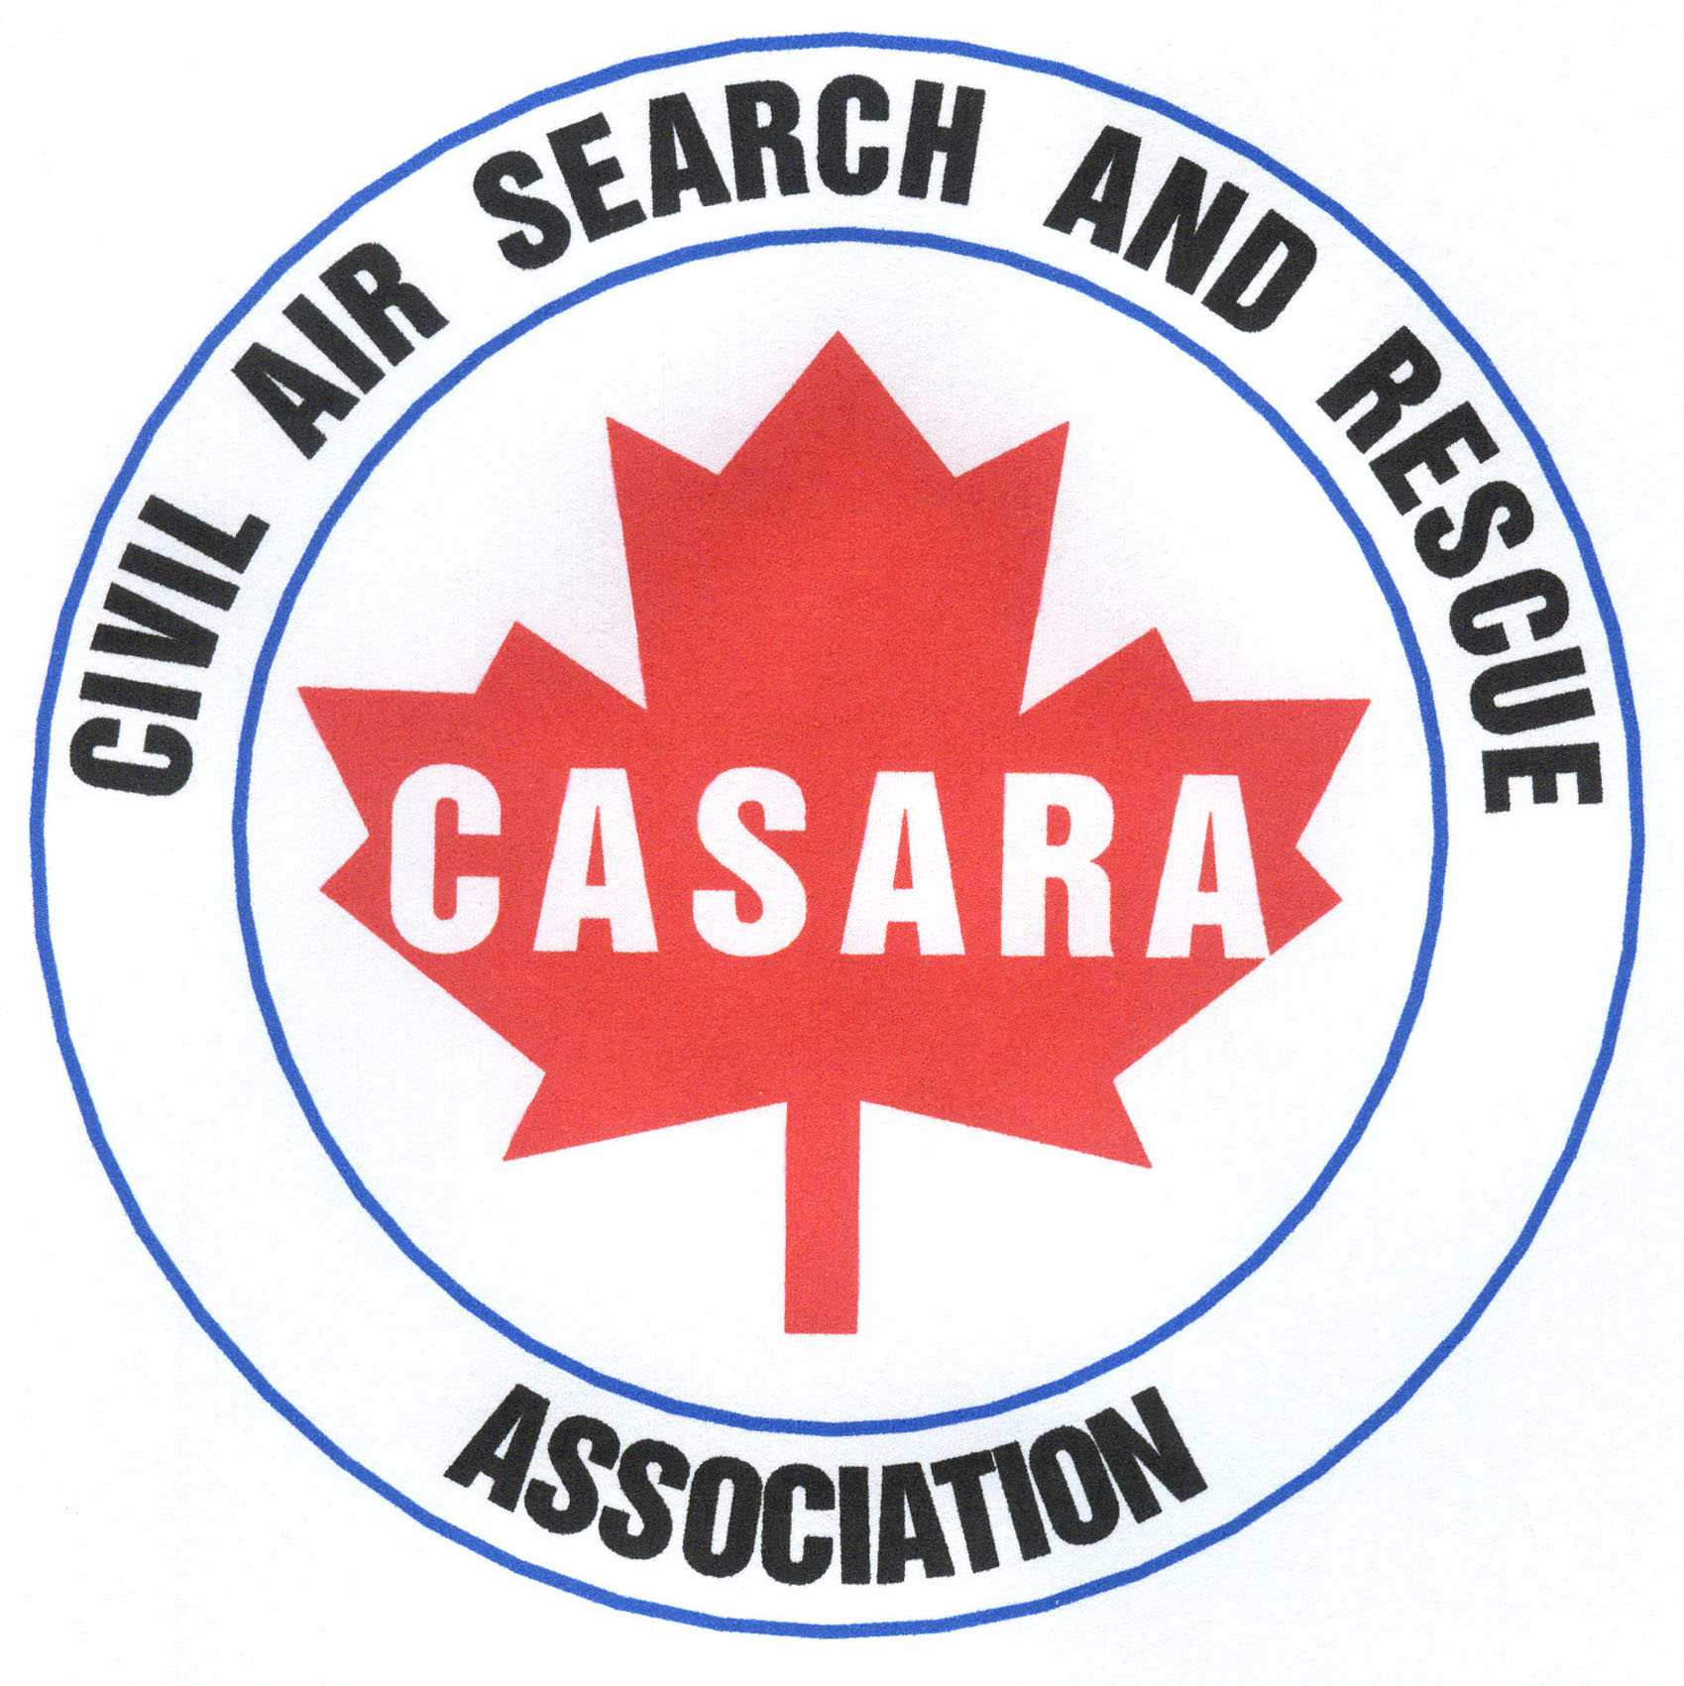
CASARA Zone 2

Newsletter

October 2012

Hello Everyone.

To keep everyone up to date with what we have achieved from the beginning of our year in May 2012. We have included a quick list of exercises and events.

- May 5, 2012 Zone 2 AGM.

- May 8, 2012 Call from Zone 1 to aid with supplying 12 military
Spotters for a search, Zone 2 were unable to assist, as only one Spotter was available.

- May 9, 2012 JRCC call: For Zone 2 to be on standby due to Zone 1
Inactive & Hercules out of Province- (18 hours).

- May 15-21, 2012 RCMP call: Search for missing boater, Lake Manitoba.

- June 9, 2012 Zone 2 SAR Awareness Open Day.
Flights grounded due to weather.
Survival talk with Ground Search & Rescue.

- July 5, 2012 JRCC call: Search for ELT. Signal terminated before
search commenced.

- July 10, 2012 Zone 2 Currency Flight.

- July 15, 2012 Zone 2 Academic Quiz, 4 teams competed for prizes.
Questions based on CASARA, Spotter & Nav training.
ELT ground search also part of the quiz.

- July 26, 2012 RCMP call: Search for missing child, Lake of the Prairies

- July 28, 2012 Brandon Flying Club breakfast. CASARA members
attended with display and information leaflets.

- Aug 10, 2012 Zone 2 Currency flight, turned into JRCC call for ELT
search by air and then by ground vehicle.

- Aug 10, 2012 Zone 2 members attended funeral for a CASARA
members husband in Souris.

- Aug 28, 2012 Zone 2 Training flight with new Garmin Aera GPS

- Sept 9, 2012 Zone 2 SAREX. Two flights were planned for currency
only one went ahead as no spotters were available.

- Sept 18, 2012 Zone 2 Currency flight

- Sept 29, 2012 Zone 2 participated in a Joint SAR exercise with multiple
Agencies, in the Riding Mountain area.

- Oct 14, 202 Zone 2 SAREX & Project Lifesaver

As you can see, we have been a busy organization and my sincere thanks to our regulars for allowing us to achieve this success.
As always, a volunteer organization is only as good as the enthusiasm and support of its members.

For Zone 2 to continue to be a professional organization requires planning and budgeting. To plan any events requires that members volunteer their time and it has been increasingly difficult to achieve this due to other commitments and maybe some mis-communication.

It is time to plan for the remainder of the year and we wish to open this to members, to tell us, what you would like us to plan, train, and include in our future events?

All who attended enjoyed the Academic quiz so we will include a winter & a spring quiz. This will cover the academic side of CASARA training that we each have to complete but in a fun way.

CASARA MB has noted that it does not have any certificates in place to give out to retiring CASARA members and Zone 2 feels that this should be remedied. John Davidson, Provincial President agrees and suggests Zone 2 design a certificate, that if accepted would be used by CASARA MB and National.

I suggest we open a competition to design a certificate to celebrate a member’s worthwhile volunteer contribution to CASARA in any position, on retirement.

This competition has very few rules; the design can be any media, computer, artwork, etc and can be done by family members or friends. It will continue until the end of the year in May 2013. The successful design put forward and voted on, will be sent to CASARA MB for decision and acceptance.
CASARA National is in the process of designing a new website with links to the Provincial websites, it is still in its trial stages but should be a more up to date venue for finding information and posting news and reports.

The website we have at present will continue and has reports and news of Zone 2 activities updated regularly; this can be found at www.casaraman.org under Zone 2

A preliminary schedule for the coming winter and spring once finalized will be posted on Zone 2’s schedule on the website, but these are some of the ideas to put forward.

- Wed, Oct 24, 2012 Zone 2 Night exercise
(confirmed)

- Sun, Oct 28, 2012 Academic Winter quiz changed from Oct 27, 2012 (confirmed)

- Sat, Nov 24, 2012 SAREX/Currency flights & Christmas lunch
(confirmed)

- Jan time off Currency flights if needed & weather permits

- Sun, Feb 3, 2013 Zone 2 SAREX / Academic

- Sat, Feb 16,2013 Zone 2 SAREX / Academic

- Sun, March 3,2013 Spring Academic quiz

Confirmation of these dates will be posted on the website and a newsletter will be handed out at another meeting to keep all members informed. This will allow everyone to add the events to their personal calendars.

Here are a few statistics for you:
Zone 2 According to the CMS, has approx 50 members in total.
27 active members (members who have put themselves on an active list, to be called out if & when needed.)
4 current Pilots, 6 Navigators, 9 Spotter’s, although weight is an issue in smaller aircraft, not all spotters who are current can act as spotters in the field.
There are approx 12-15 regular members who attend meetings and exercises.

Bev Williams
Zone 2 Commander
You can reach me at any time with questions, suggestions, ideas, comments or complaints (I hope not too many of those!)

Home: Tel & Fax 204 379 2902, Cell 204 751 2044. Email BevCW@inetlink.ca

